**IDEATION PHASE**

Empathize & Discover

**Empathy Map canvas:**

An Empathy Map Canvas is used to gain a deeper understanding of a user or customer. It helps teams visualize what the user thinks, feels, says, and does, along with their pains and gains. This tool is commonly used in design thinking and user-centered development to foster empathy and align the team’s perspective around the target audience's experiences and needs.

Empathy Map:

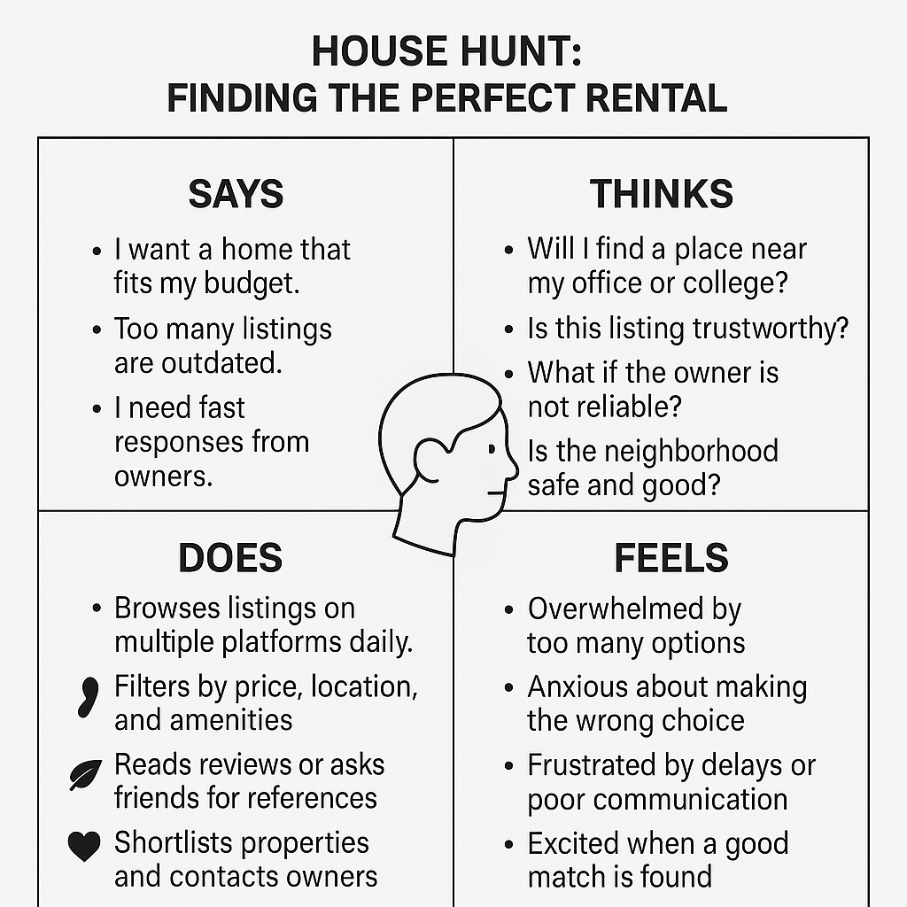

Reference: https://www.mural.co/templates/empathy-map-canvas